Big data lab

24th may 2022

Starting hadoop

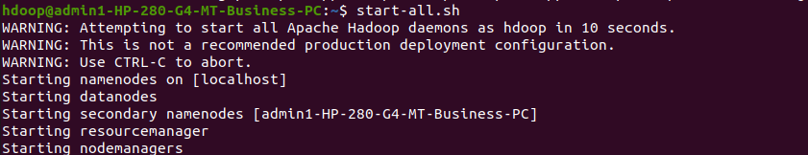

1. Create a directory named by your name



2. Add two empty files into it



3.List all the files in the directory that you have created

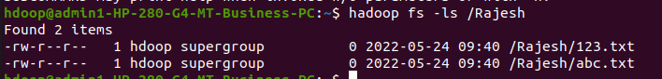

4 Create one more directory by your usn and put that inside the directory of your name.



5.Create a file in your local system by the name_usn.txt and add the contents as"Syntax to list Is command is hadoop fs -Is "

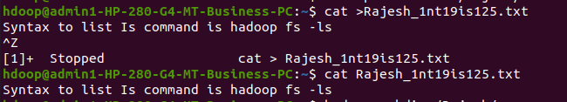

put the file usn_name.txt in your hdfs directory called usn

Put empty file of hdfs into the local file system



use my command to move files from local file system and hdfs file system



Experiment of cp command



display the total size of all the files in name directory

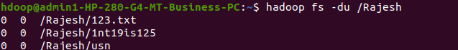

Display each file size in usn directory Use stat command on name and usn directory



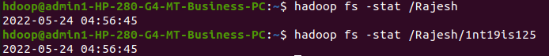

Illustrate the use of append command

